

Government College University, Lahore

## DEPARTMENT OF COMPUTER SCIENCE

**PROJECT PROPOSAL**

**CLINICS MANAGEMENT SYSTEM**

|  |  |
| --- | --- |
| **SUBMITTED BY:** | Muhammad Zeeshan Yousaf  **&** Ahmad Faisal |
| **ROLL NO:** | 259-BSCS-19 **&** 213-BSCS-19 |
| **SECTION:** | E1 |
| **SEMESTER:** | 4th |
| **COURSE:** | Visual Programming |
| **SUBMITTED TO:** | Ma’m Asma Kanwal |

CLINICS MANAGEMENT SYSTEM

# OVERVIEW

A clinic (or outpatient clinic) is a health facility that is primarily focused on the care of outpatients. It typically covers the primary care needs of populations in local communities, in contrast to larger hospitals which offer more specialized treatments and admit inpatients for overnight stays.

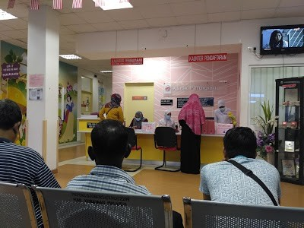In general, all clinics will have **consultation rooms, patients, doctors**. Of course, there are other support staffs such as nurses, admin, cleaners and other related staff but in this project, they will not be considered. And they have some relationships such as **Patient will be referred to a certain consultation room.** And all consultation rooms have specific doctor on duty. The overall doctors that attach to the clinics is more than the doctors on duty. Patient normally will be prescribed some medicines according to his/her health problem. And some other general situation.

Figure 1 Clinics Consultant Counter

This is the project proposal and user guide for the C# *Clinics Management System* Semester Project.

## What included in this PROJECT?

* RECEPTIONIST
* DOCTOR
* PATIENT
* DATABASE

Above are the main roles of the project. Patient is dependent on Receptionist.

DOCTOR and RECEPTIONIST both have different login accounts.

### RECEPTIONIST

Every Receptionist Username / ID and password is already stored in database and no one can change without admin (which is not in this project).

The Username / ID of every receptionist is formatted as (rec_*[name]* ).

The password of every receptionist is formatted as ( *[name]*123 ).

(Name in small letters without spaces.)

#### Receptionist Accounts saved in database

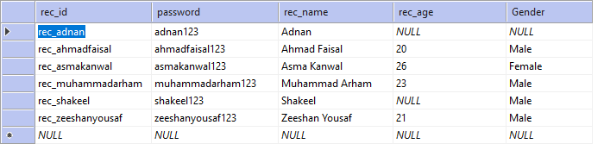

DASHBOARD FOR RECEPTIONIST

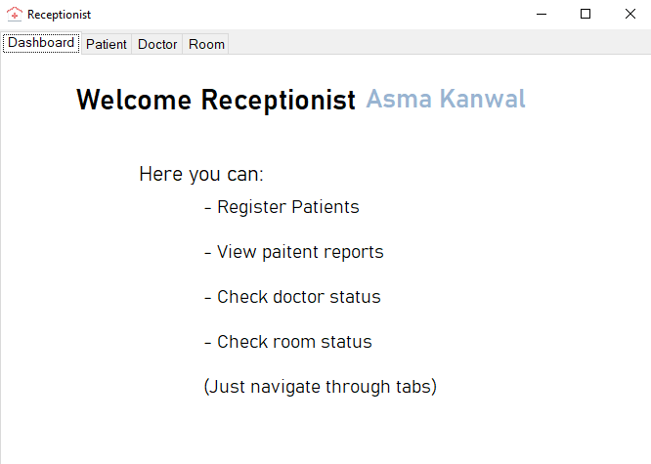

PATIENTS MANAGEMENT BY RECEPTIONIST

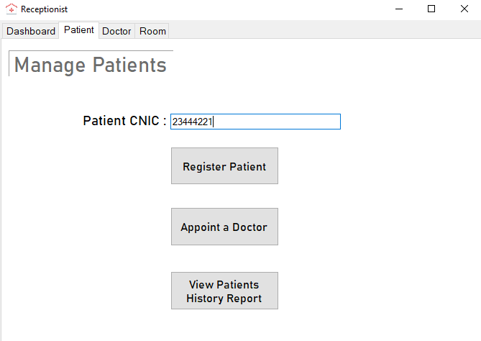

Receptionist can do above things by first providing a new CNIC of the patient or exiting.

Get Doctor information

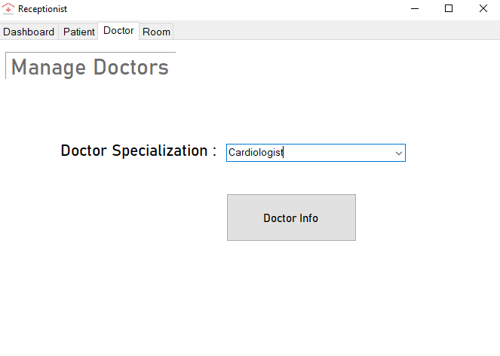

GET INFORMATION OF ROOMS

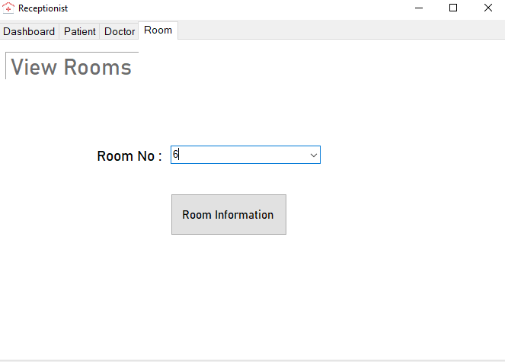

### DOCTOR

Every doctor Username / ID and password is already stored in database and no one can change without admin (which is not in this project).

The Username / ID of every doctor is formatted as (dr_*[specialization]* ).

The password of every doctor is formatted as ( *[specialization]*123 ).

(Name in small letters without spaces.)

#### DOCTORS SAVED IN DATABASE

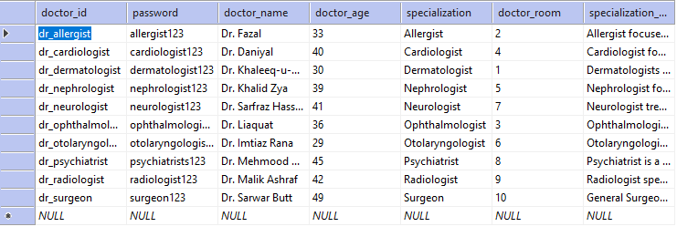

DASHBOARD OF DOCTOR

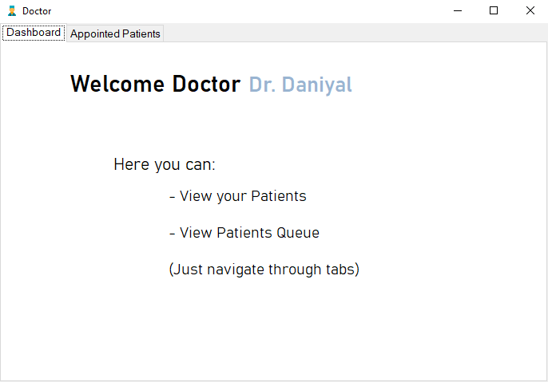

APPOINTMENT MANAGEMENT

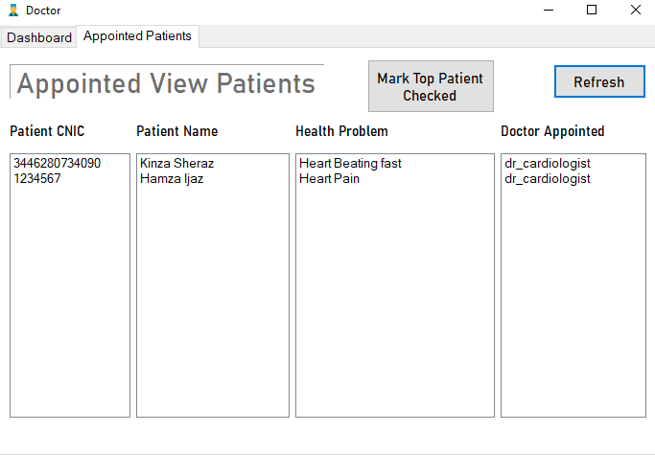

Here doctor can see his appointments with patient and after completing appointments he can remove that patient from appointments.

These are the appointments that receptionist has scheduled for patients., every time a new appointment scheduled for specific doctor, that will appear hear.

**Note: Your need refresh to first list down all appointments.**

### DATABASES

Below is the database tables and procedures:

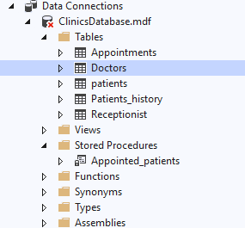 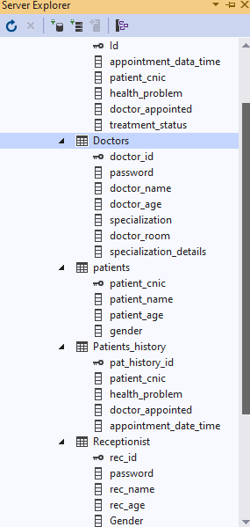

IMPORTANT NOTE:

THE APPLICATION DATABASE WILL NOT WORK UNTILL YOU SPECIFY THE PATH OF DATABASE FILE IN DATABASE CONNECTION.

IN MY CASE THE DATABASE CONNECTION STRING IS (which include the db file path):

|  |
| --- |
| static SqlConnection conn = new SqlConnection(@"Data Source=(LocalDB)\MSSQLLocalDB;AttachDbFilename='F:\My Git repositories\Clinics-Project\Clinics Management System\Clinics Management System\ClinicsDatabase.mdf';Integrated Security=True;Connect Timeout = 30"); |

In above given path is:

|  |
| --- |
| F:\My Git repositories\Clinics-Project\Clinics Management System\Clinics Management System\ClinicsDatabase.mdf |

**YOU WILL NEED TO CHANGE THE PATH TO RUN THE DATABASE WITH APPLICATION.**